FTP Installation Instructions
FileZilla Open Source Software

June 2011

Prepared by:
Julio Ortiz
IT Operations Manager

Introduction

This document provides the instructions on how to download and install the free (open source) FileZilla File Transfer Protocol (FTP) software to perform file transfers to/from abarca health’s servers.

These instructions are provided as a convenience to abarca health’s customers and partners in order to provide an example on how to configure an FTP application to be able to connect to abarca health’s FTP server. Nevertheless, other FTP software clients in the marketplace support this type of connection, and therefore FileZilla is only a recommendation and not a requirement.

Given FileZilla’s Open Source licensing, abarca health cannot provide technical support for this product or guarantee its functionality in interacting with our servers.

Please contact your Information Technology department to install and test the program with sample files before using it with real data.

Installation and Configuration Instructions

The following are the recommended steps to install the FileZilla FTP client. However, certain steps may be different for your particular environment. Therefore, always consult your IT department before installing this software in your system.

Step 1 – Download and Install

- Go to the following link: http://filezilla-project.org/download.php?type=client

- Click the recommended installation link under Windows label. The current version as of the date of this document is 3.5.0.

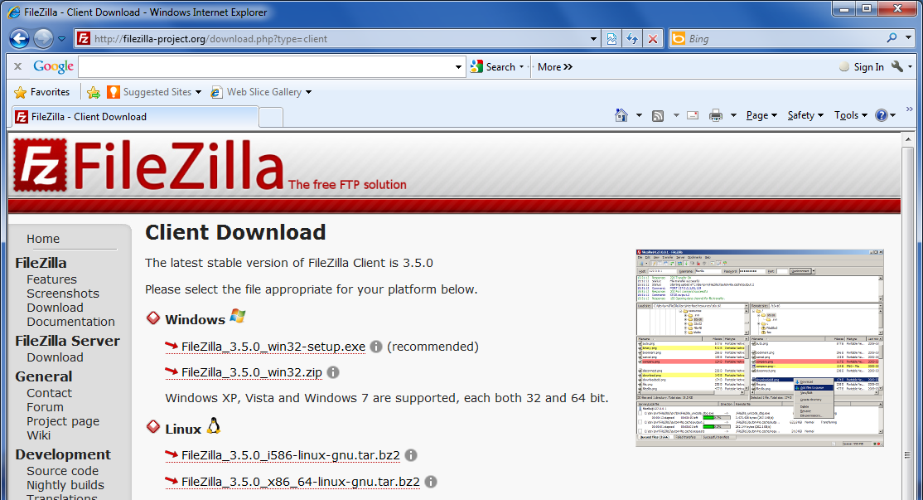

- The ‘Download’ page will appear and a ‘File Download – Security Warning’ dialog box will pop up. Please click the ‘RUN’ button in the dialog box to start downloading the application.

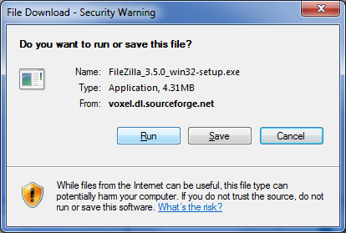

- When the application finishes downloading, the following ‘Security Warning’ dialog box will pop up. Click the ‘RUN’ button to start installing the application.

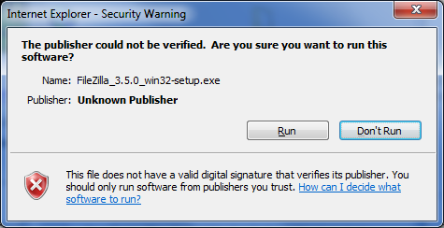
- Read the license agreement and click the ‘I Agree’ button to continue.

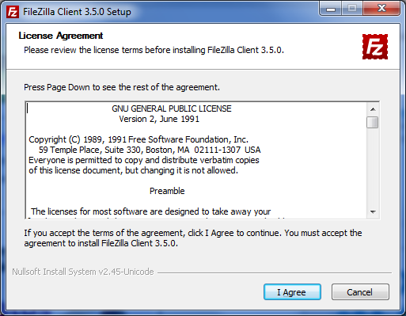

- Select the “Anyone who uses this computer (all users)” option and click the ‘Next’ button.

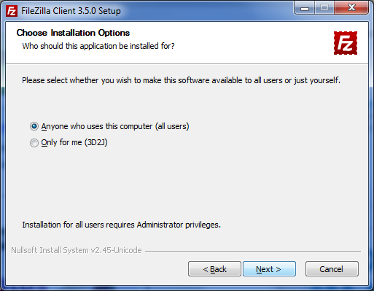

- On the ‘Choose Components’ window, check all the components and then click the ‘Next’ button.

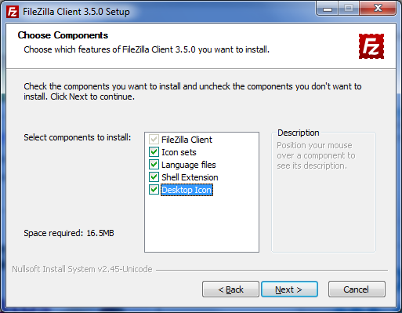

- Leave the default values on the ‘Choose Install Location’ window and then click the ‘Next’ button.

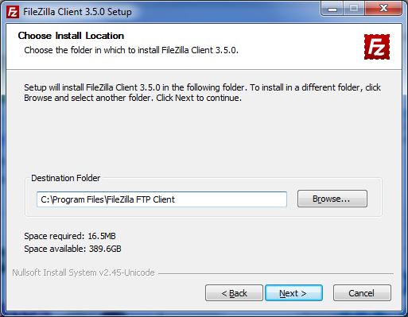

- Leave the default values on the ‘Choose Start Menu Folder’ window and then click the ‘Install’ button.

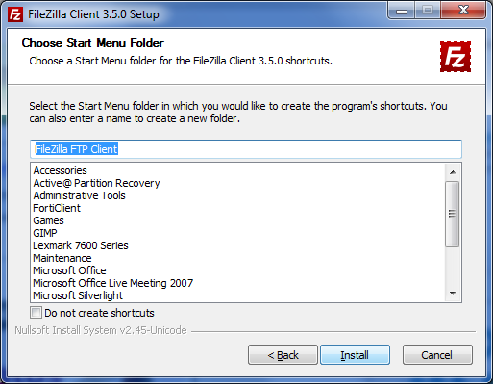

- Please wait until the installation process completes.

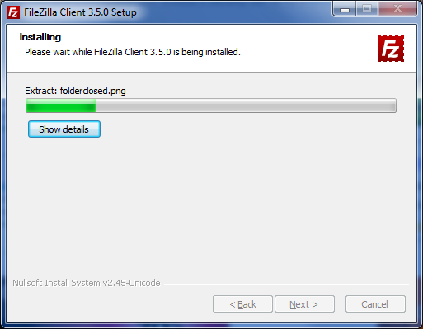

- Leave the ‘Start FileZilla now’ checkbox checked and then click the ‘Finish’ button.

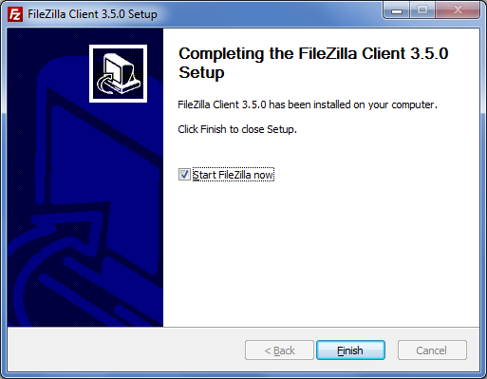

- The FileZilla application will open and then click the ‘OK’ button on the ‘Welcome to FileZilla’ dialog box.

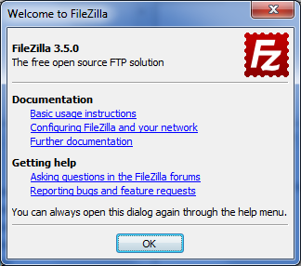

Step 2 - Configuration

- For a one time only, please configure the FileZilla FTP application. Click on the menu the ‘File’ option and then click on the ‘Site Manager…’ option.

- When the ‘Site Manager’ dialog box appears, click on the ‘New Site’ button.

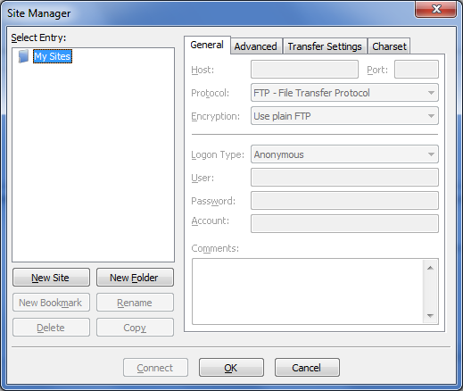
- Rename the appearing ‘New Site’ with the name Abarca FTP as shown in the picture.

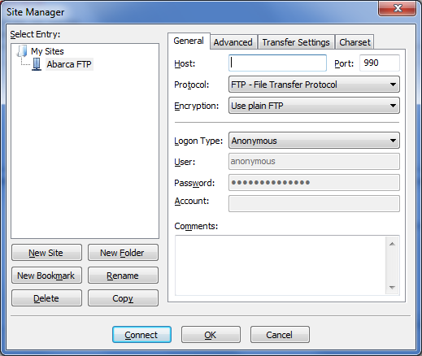

- Configure the remaining values according with the following screenshot:

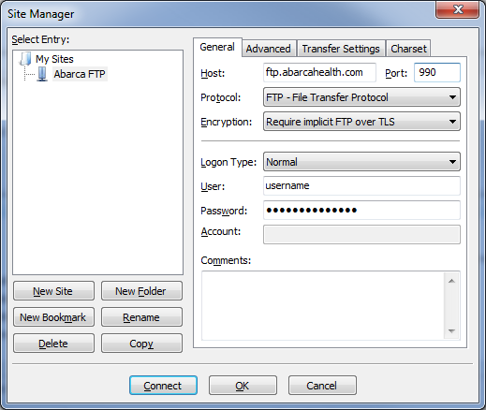

Abarca FTP Configuration Review:

Host: ftp.abarcahealth.com
Port: 990
Server type: FTPS – FTP over implicit TLS/SSL
Logon type: Normal
User: {Provided}
Password: {Provided}
Comments: {Optional}

Very important: Please ensure that ports 1550 thru 1599 are opened in the company’s firewall. Otherwise, the FTP Program will not be able to fully connect to the FTP server (i.e. the program will not be able to see the remote directory listing).

- Click on the ‘Transfer Settings’ tab and then select the ‘Passive’ radio button.

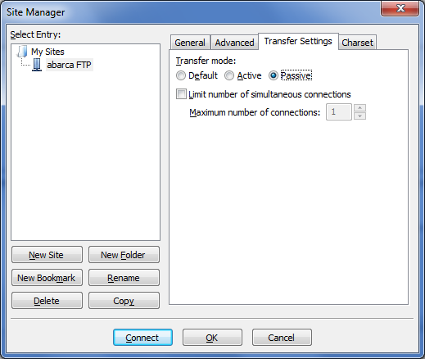

- Click the ‘OK’ button to save the configuration data. This way you do not have to enter the configuration data again.

We are done configuring FileZilla for the secured Abarca FTP connection. It is fine to close the application now.

Step 3 - Usage Instructions

- Open the FileZilla Client.

- Select the ‘Site Manager’ Icon on the Toolbox menu and then select ‘Abarca FTP’.

This will allow the FileZilla FTP Client to connect automatically using the configuration information provided on the previous steps.

