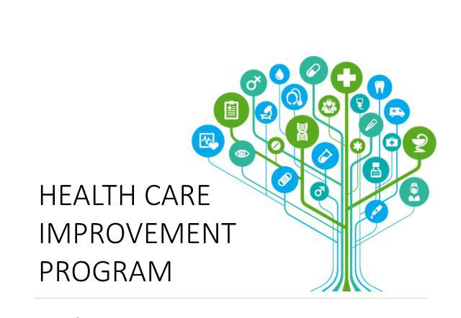

PUERTO RICO HEALTH INSURANCE ADMINISTRATION ADMINISTRACIÓN DE SEGUROS DE SALUD DE PUERTO RICO

HEALTH CARE IMPROVEMENT PROGRAM BENCHMARKS
FIRST YEAR
BENCHMARKS REFERENCE GUIDE
GOVERNMENT HEALTH PLAN PROGRAM
JANUARY 1, 2023 – SEPTEMBER 30, 2025
Revised June 14, 2022

HEALTH CARE IMPROVEMENT PROGRAM 2021 BENCHMARKS REFERENCE

CHRONIC CONDITIONS | SCORED MEASURES | 2021 BENCHMARKS  (1/1/2021-12/31/2021)
Medicaid/Federal, State, and CHIP Chronic Conditions
Diabetes | - Comprehensive Diabetes Care:
 | - Hemoglobin A1c (HbA1c) testing | 82.88%
 | - Hemoglobin A1c (HbA1c) poor control (>9.0%) (ACCM) | 45.4%*
 | - BP Control (<140/90 mm Hg) | 58.2%*
 | o Eye exam | 29.8%
 | o Kidney Health Evaluation for Patients with Diabetes | 95.15%
 | - Admissions/1000 | 156
Asthma | - Admissions/1000 | 188
 | - ED Use/1000 | 1072
 | - PHQ-9 | 16.08%
Medicaid/Federal and State Chronic Conditions
Severe Heart Failure | - Admissions/1000 | 604
 | - PHQ-9 | 24.24%
Hypertension | - ED Use/1000 | 805
Chronic  Obstructive Pulmonary  Disease (COPD) | - Admissions/1000 | 392
Chronic Depression | - Follow up after Hospitalization for Mental Illness: 7 days | 50.66%
 | - Follow up after Hospitalization for Mental Illness: 30 days | 79.67%
 | - Inpatient Admission/1000 | 235

* HEDIS Measures and Technical Resources:
Comprehensive Diabetes Care (CDC): https://www.ncqa.org/hedis/measures/comprehensive-diabetes-care/

HEALTHY PEPOLE INITIATIVE | SCORED MEASURES | 2021 BENCHMARKS  (1/1/2021-12/31/2021)
BCS | - Breast Cancer Screening | 61.28%
CCS | - Cervical Cancer Screening | 52.32%
CBP | - Controlling High Blood Pressure | 30.91%
SSD | - Diabetes Screening for People with  Schizophrenia or Bipolar Disorder who are using Antipsychotic Medications. | 64.39%
FUH | - Follow-Up After Hospitalization for Mental Illness: 30 days | 78.77%
ACCESS / AVAILABILITY OF CARE
AAP | - Adults’ Access to Preventive/Ambulatory Health Services | 71.44%
ADV | - Annual Dental Visit | 51.29%
OEV | - Oral Evaluation, Dental Services** | TBD
PPC | - Timeliness of Prenatal Care | 57.67%
 | - Postpartum Care | 42.38%
OTHER UTILIZATION
W30 | - Well-Child Visits First 30 months of Life | 71.0*
WCV | - Child and Adolescent Well-Care-Visits | 46.1*

ER HU INITIATIVE | SCORED MEASURES | 2021 BENCHMARKS  (1/1/2021-12/31/2021)
ER | Overall emergency room utilization rate x 1,000 on identified population with 7 or more visits to the emergency room | 10,763

* HEDIS Measures and Technical Resources:
Child and Adolescent Well-Care Visits – NCQA: https://www.ncqa.org/hedis/measures/child-and-adolescent-well-care-visits/
**TBD – To be determined. 2022 Child Core Set New Measure

