PUERTO RICO HEALTH INSURANCE ADMINISTRATION
ADMINISTRACIÓN DE SEGUROS DE SALUD DE PUERTO RICO
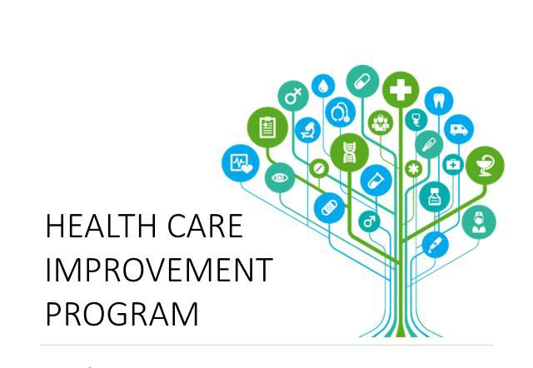

HEALTH CARE IMPROVEMENT PROGRAM CODE BOOK I GOVERNMENT HEALTH PLAN PROGRAM
JANUARY 1, 2023 – SEPTEMBER 30, 2025
Code Book for the first year

  - Scored Measures for 2021-2022

Readmissions rate
Technical specifications | Plan all cause (PCR) metric: HEDIS MY 2020 & MY 2021, Volume 2 technical specifications.
PHQ-9
Definition | The PHQ-9 is a multipurpose instrument for screening,  diagnosing, monitoring and measuring the severity of depression.
Numerator | Patients in the denominator who were screened with a PHQ-9 test during the measurement period.
Denominator | All eligible population with the condition during the measurement year or period.
Continuous enrollment | N/A
Allowable gap | N/A
Description | Codes
CPT: 96127 Brief emotional/behav assmt
G8431: Screening for depression is documented as being positive and a follow-up plan is documented Short Description: Pos clin depres scrn f/u doc
G8510: Screening for depression is documented as negative, a follow-up plan is not required; Short description: Scr dep neg, no plan reqd
Other: Supplementary Data (test peformed by case managers among others)
Exclusions | N/A
Admissions/1000
Definition | Discharges for a principal diagnosis of selected conditions (see HCIP Manual) per 1,000 enrolled population.  Excludes obstetric admissions and transfers from other institutions.
Numerator | Discharges for members with a principal diagnosis (ICD-10-CM) which meet the criteria of the applicable initiative/condition

Denominator | All eligible population with the condition during the measurement year or period.
Continuous enrollment | N/A
Allowable gap | N/A
Description | Codes
 | Revenue codes: See Appendix A
Exclusions | Exclude cases: With admission source for transferred from a different hospital or other health care facility UB04 Admission source - 2, 3)  With a point of origin code for transfer from a hospital, Skilled Nursing Facility (SNF) or Intermediate Care Facility (ICF), or other healthcare facility (Appendix A) (UB04 Point of Origin - 4,5,6) - With missing gender (SEX=missing), age (AGE=missing), quarter (DQTR=missing), year (YEAR=missing), principal diagnosis (DX1=missing)
ED (Emergency room) Use/1000
Definition | For members 18 years of age and older, the number of observed emergency department (ED) visits during the measurement year.  *ED visits for a principal diagnosis of selected conditions (see HCIP Manual).
Numerator | The number of all ED visits during the measurement year.  Count each visit to an ED once, regardless of the intensity or duration of the visit.  *ED visits for a principal diagnosis of selected conditions (see HCIP Manual).
Denominator | All eligible population with the condition during the measurement year or period.
Continuous enrollment | N/A
Allowable gap | N/A
Description | Codes

CPT: 99281-99285, 99288
Place of service code: 23
Use the following reference:
- ED Visits from HEDIS Ambulatory Care (HEDIS MY 2020 & MY 2021, Volume 2 technical specifications).
- ED Use ICD10 codes tab from the Code Book II Health Care Improvement Program
Exclusions | HEDIS MY 2020 & MY 2021, Volume 2 technical specifications:  The measure does not include mental health or chemical  dependency services. Exclude visits for mental health or chemical dependency. Any of the following meet criteria:  - A principal diagnosis of mental health or chemical dependency (Mental and Behavioral Disorders Value Set).  - Psychiatry (Psychiatry Value Set).  - Electroconvulsive therapy (Electroconvulsive Therapy Value Set).
Emergency Room High Utilizers Initiative
Definition | Overall emergency room utilization rate x 1,000 on identified population with 7 or more visits to the emergency room
Numerator | Total Number of ER Visits incurred by members with 7 or more ER Visits
Denominator | Total members with 7 or more ER Visits
Continuous enrollment | N/A
Allowable gap | N/A
Description | CPT: 99281-99285, 99288  Place of service code: 23

Exclusions | HEDIS MY 2020 & MY 2021, Volume 2 technical specifications:  The measure does not include mental health or chemical  dependency services. Exclude visits for mental health or chemical dependency. Any of the following meet criteria:  - A principal diagnosis of mental health or chemical dependency (Mental and Behavioral Disorders Value Set).  - Psychiatry (Psychiatry Value Set).  - Electroconvulsive therapy (Electroconvulsive Therapy Value Set).
(OEV) • Oral Evaluation, Dental Services
Technical specifications | DQA Measure Technical Specifications: Administrative Claims-Based Measures
(AAP) Adults’ Access to Preventive/Ambulatory Health Services
Technical specifications | HEDIS MY 2020 & MY 2021, Volume 2 technical specifications
(W30) Well-Child Visits First 30 months of Life
Technical specifications | HEDIS MY 2020 & MY 2021, Volume 2 technical specifications
(WCV) Child and Adolescent Well-Care Visits
Technical specifications | HEDIS MY 2020 & MY 2021, Volume 2 technical specifications
(BCS) Breast Cancer Screening
Technical specifications | HEDIS MY 2020 & MY 2021, Volume 2 technical specifications
(CCS) Cervical Cancer Screening
Technical specifications | HEDIS MY 2020 & MY 2021, Volume 2 technical specifications
(CDC) Comprehensive Diabetes Care
Technical specifications | HEDIS MY 2020 & MY 2021, Volume 2 technical specifications
Kidney Health Evaluation for Patients With Diabetes
Technical specifications | HEDIS MY 2020 & MY 2021, Volume 2 technical specifications
(CBP) Controlling High Blood Pressure
Technical specifications | HEDIS MY 2020 & MY 2021, Volume 2 technical specifications

(FUH) Follow up after Hospitalization for Mental Illness (7 and 30 days)
Technical specifications | HEDIS MY 2020 & MY 2021, Volume 2 technical specifications
(PPC) Prenatal And Postpartum Care
 | HEDIS MY 2020 & MY 2021, Volume 2 technical specifications
(SSD) Diabetes Screening for People with Schizophrenia or Bipolar Disorder who are using Antipsychotic Medications
Technical specifications | HEDIS MY 2020 & MY 2021, Volume 2 technical specifications

